Name : Abdul Qayyum
B-III Artificial Intelligence ( Evening )
Sir Adeel

Command = chmod
Explanation;
I created a file named test.sh and checked its permissions using the ls -l command. Initially, the file did not have execute permission. Then I used chmod +x test.sh to make it executable. After applying the command, I verified the permissions again and confirmed that the execute (x) permission was added. Finally, I ran the script using ./test.sh, and it successfully displayed the output “Hello AI Assignment.”
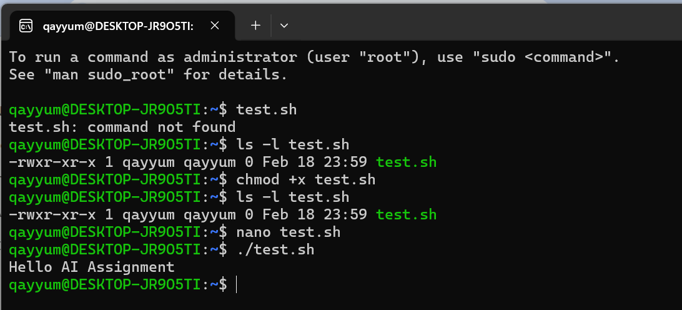

Command = ps
Purpose: To view currently running processes on a Linux system.
Explanation;
The ps command is used to see which programs or processes are currently running on a system. It helps to monitor the system, check resource usage, and manage unresponsive programs.
I first ran ps to see a simple list of processes. Then, I ran ps aux to get more details, such as the process ID (PID), the user who started the process, CPU and memory usage, and the command used to run the process.
I also filtered for a specific program using ps aux | grep firefox, which showed only Firefox processes. This demonstrates how ps can help track and manage running applications on the system.

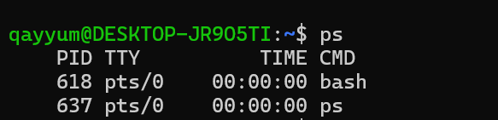

Command = kill id by PID
Explanation;
I created a dummy process using sleep 1000 and checked the currently running processes with the ps command. The sleep process appeared with PID 909. I first used kill 909 to terminate it normally. Since it was not responding immediately, I used kill -9 909 to forcefully stop the process. Finally, I verified with ps that the sleep process was no longer running. This demonstrates how the kill command can be used to stop any running process by its PID, which is helpful for managing unresponsive programs or freeing system resources.
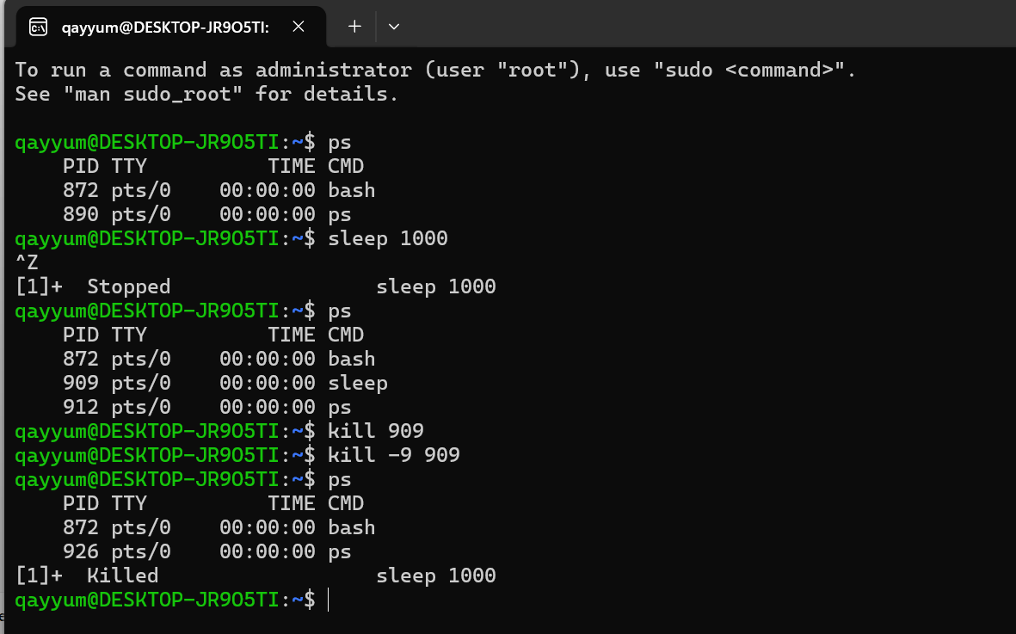

Command = sudo apt update
Explanation;
I ran sudo apt update to fetch the latest package lists from the repositories. Using sudo allowed me to run the command as an administrator. This ensures that my system knows about the newest updates for all installed packages, which is important for system security and keeping software up-to-date.
